DS4000 Storage Manager Client Upgrade

Note: This version of the Storage Manager Client is compatible with versions of DS4000 firmware up to, and including, 6.12.40.0. Consequently, this Storage Manager will not allow you to upgrade your DS4000 storage system to any firmware level later than 6.12.40.0.
Please check the DR550 Versions Guide at the IBM Total Storage DR550 Support website –
http://www-1.ibm.com/support/docview.wss?rs=1116&context=STYUE4&dc=DA400&q1=ssg1*&uid=ssg1S7001648&loc=en_US&cs=utf-8&lang=en
for detailed information on the compatibility of software and firmware versions of various components in the solution.

Process / Steps

Preparing for the upgrade
The following procedure checks whether there is enough space available in the /tmp or /opt filesystem for the installation of SMclient. If this is not the case this procedure extends the space in these filesystems. Note, there should be at least 500 MB free space available in the filesystem
- Logon to node2 as dr550 and su to root as before
- df –k /tmp
- df –k /opt
If either of the two Filesystems has less than 500 MB free space, do steps 4 through 10 for each of the filesystems that needs more space.
- # smit chfs
- move cursor to Change/Show Characteristics of an Enhanced Journaled File System

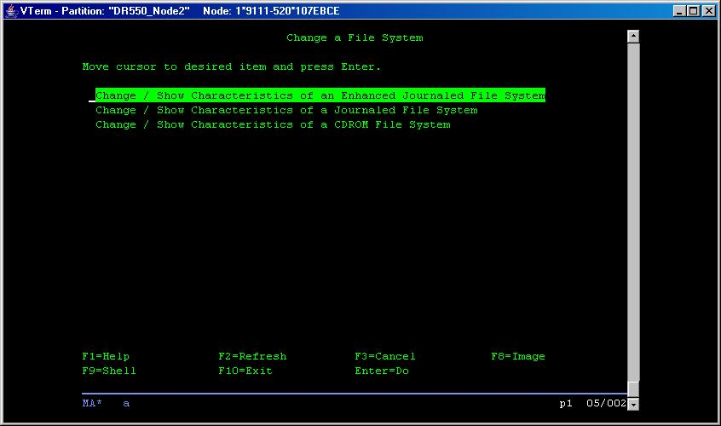
- Press Enter and you will get a selector screen. Move cursor to /tmp as shown below:

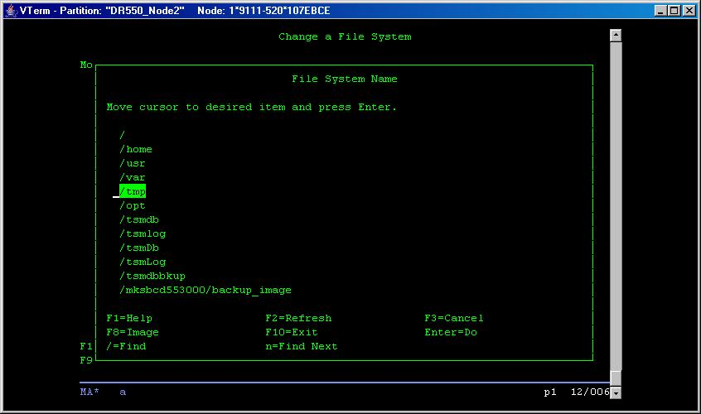

- press Enter and on the dialog screen move cursor to number of units under Size of File system and change the leading digit to 9 (we are trying to approximately increase the size to 500 MB)

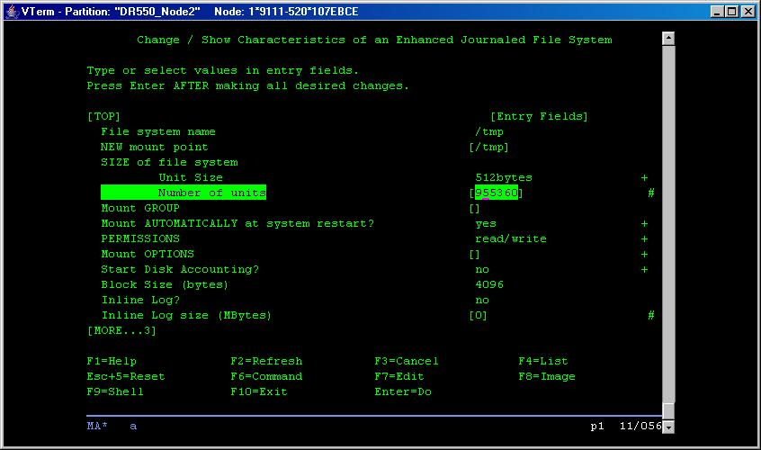

- Press Enter

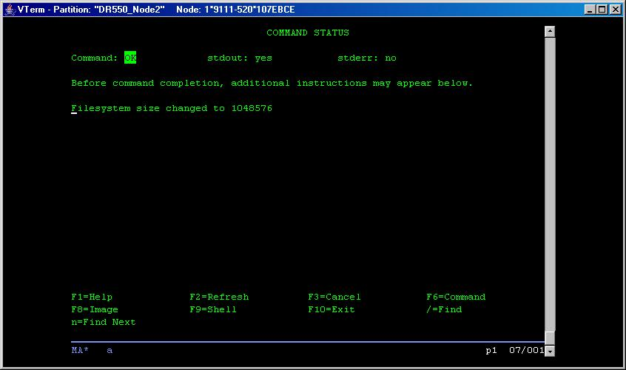

- Repeat the above sequence, if needed, this time choosing /opt, in the filesystem selector screen and increase the size as above to about 500 MB
- You can get out of smit by typing ESC-0

Uninstalling SM Client
- # smit install
- move cursor to Software Maintenance and Utilities
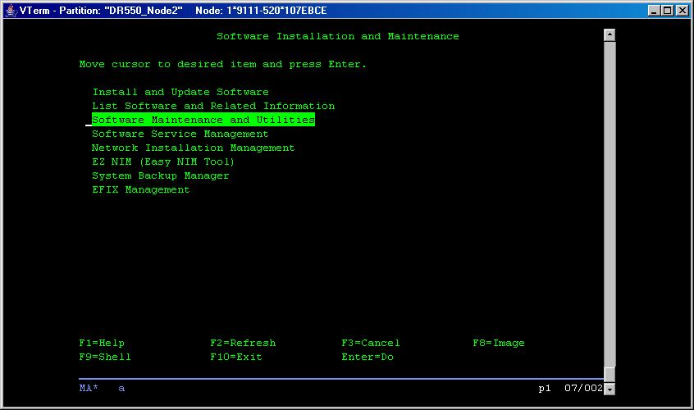

- Press Enter and move cursor to Remove Installed Software
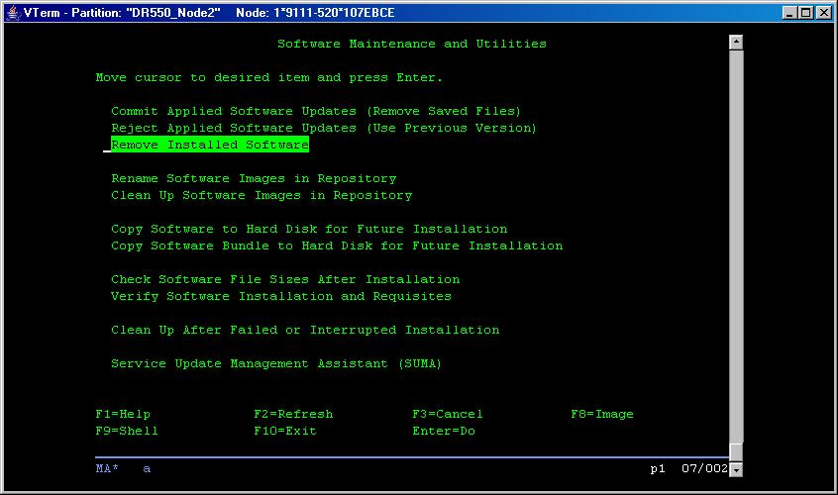

- Press Enter

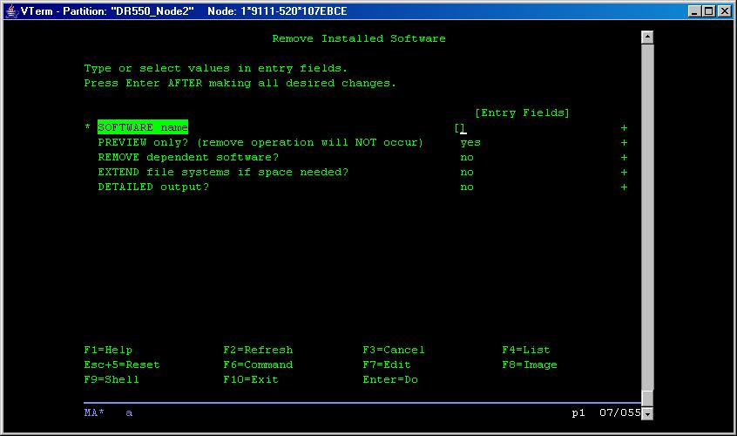

- press ESC-4 to get the selector screen to select SMclient.aix.rte (using /SMclient to locate it and then ESC-7 to select it) for software name and press Enter

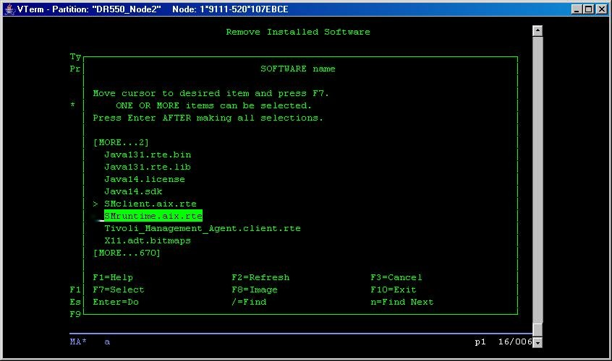

on the next screen change Preview only? Field to no (using ESC-4 selector or TAB)

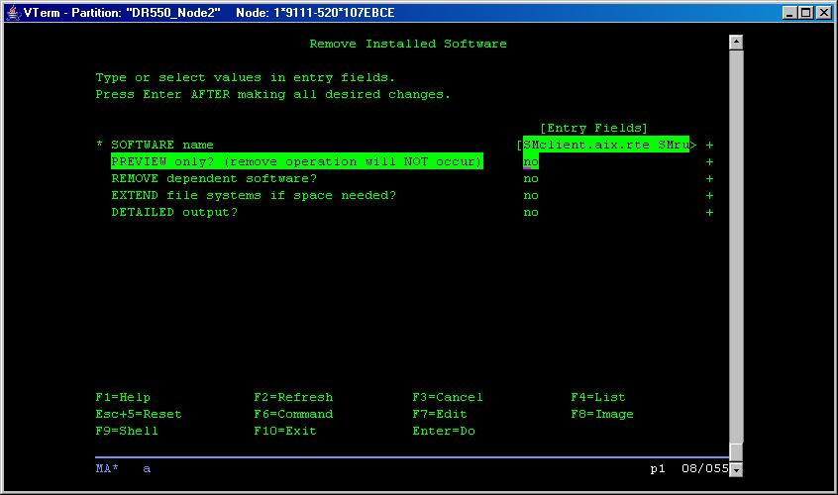

- Press Enter

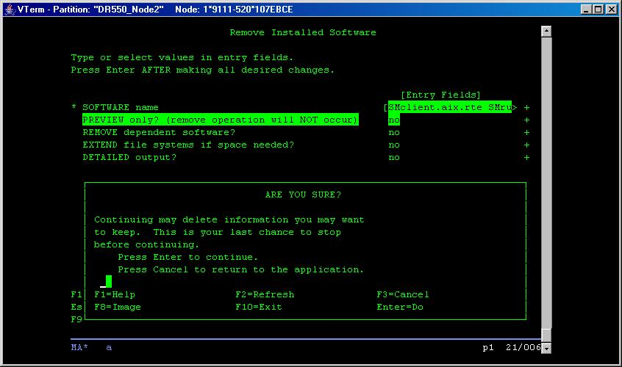

- Press Enter again to confirm and the uninstall should complete fairly quickly removing SMclient software (again look for ok at the top left)

You are now ready to install the SM client. SMclient code is release 9.12.65.10.

Install SM Client Code Version 9.19.65.81

- If you have an HMC that is used to manage the DR550, from the HMC press PrtSc and select DRS_550_NODE2. If there is no HMC use a workstation that has xserver on it and open an xwindows session on it.
- Login to node2 as dr550 and su to root
- Load the SM Client CD which has the code downloaded from website.
(This step and steps 4,5 9 and 15 apply only if you have downloaded the code onto a CD or DVD. If you have directly ftp’d the image to the Dr550, then you should skip steps 4 and 5 and copy the image from the directory you have the image in, instead of from /mnt as shown in step 9)
- mount the CD with the mount point (file system) called /mnt:
# mount –v cdrfs –o ro /dev/cd0 /mnt
- Change to the filesystem on CD:
# cd /mnt
- Make a directory (e.g. DS_Install) in the /tmp filesystem:
# mkdir /tmp/DS_Install
- Change directory:
# cd /tmp/DS_Install
- Clean up the install directory:
# rm /tmp/DS_Install/*
- Copy the file from CD (or from the directory you have downloaded the image to):
# cp /mnt/* /tmp/DS_Install
Make the file executable:
# chmod 755 *
- Start the X-Windows environment:
# startx
- Set a system variable for the installation:
# export IATEMPDIR=/tmp
12) Change directory to where the installation file is located.
# cd /tmp/DS_Install
- Start the SM Client Installation
# sh *
➔ this step will start the Java Installation GUI, which looks like in Windows.
- Select yes to accept license agreement and default on all other screens and just follow the onscreen instructions to complete installation.
- The Install Program will also create a folder /opt/IBM_DS4000. The Folder /opt/IBM_FAStT will still be there, but the install program goes back and deletes any temporary files. You can now delete the image file with the following command
# rm /tmp/DS_Install/*
- Once the installation has completed successfully you can unmount the CD and remove it. Enter the following commands as “root” to unmount and eject the CD.
  - # cd /
  - # umount /mnt
  - Now you can eject the CD from the server.
- Start Storage Manager Client and rediscover the DS4100 to get it ready for firmware installs
- SMclient
- Click on Tools button and select Automatic Discovery from the drop down menu
- The Storage manager will rediscover the storage units and add entries for it in the GUI

