Let me explain how to read this report (VEHAUDIT.CPYDST).

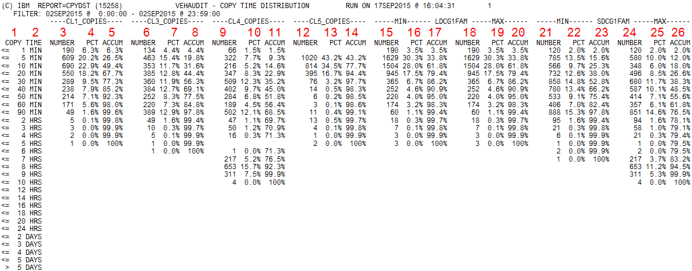

Column 1 - "copy time" = the copy was done during this time, for example, the first line "<==1 min" shows the number of copies done less than in one minute
2 - min/hours/days
3 - the number of copies done to cluster CL1
4 - % of total copies
5 - "accumulated" %
6, 7, 8 - the same as 3, 4, 5, but for CL3
9, 10, 11 - the same for CL4
12, 13, 14 - the same for CL5
15-20 - counters for family LDCG1FAM
I don't know which clusters are included into this family. Let's say FAMx is joining two clusters - CLa and CLb.
The copies from other clusters are defined to go to this FAMx.
For example, logical volumes from cluster CLc should go to FAMx (i.e. to CLa and CLb),
and they go, but the time to do the copy CLc-->CLa and the time CLc-->CLb could be different,
for example, 2 minutes for CLc-->CLa and 10 minutes for CLc-->CLb.
Here 2 min = "minimal" time, 10 min = "maximal" time for the copies of considered logical volume to FAMx.
15 - the number of copies done to family LDCG1FAM, where "minimal" time is taken into account
16 - %
17 - "accumulated" %
18, 19, 20 - the same, but "maximal" time is taken into account
21-26 - the same as 15-20, but for the second family SDCG1FAM

The cluster families could be defined by DEFDL parameters, like in this example:
DEFDL= aaaaa 0;
DEFDL= bbbbb 2 FAMILY1;
DEFDL= ccccc 3 FAMILY2;
DEFDL= ddddd 4 FAMILY1;
DEFDL= eeeee 5 FAMILY2;

